Defect (Bug) Report – Heading too little

Title: About Us Page- Page content showing excessive wide space

Date: 28/06/2021

Project URL: JustInMind Prototype

Defect Page: About Us Page

Description:

ID – 001

**Steps to Reproduce:**

1. Navigate to Landing page
2. Click on About Us
3. Observe the bug

Screenshot:

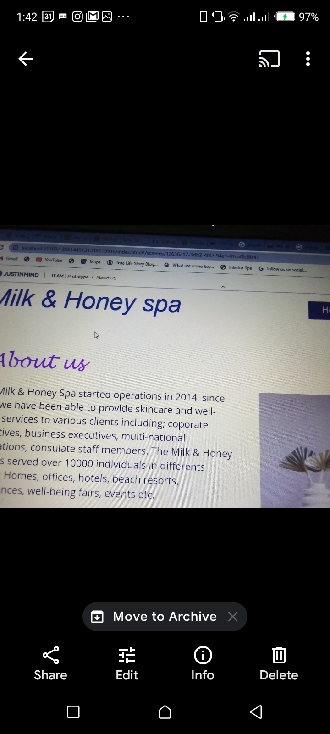

Bug severity: Low

Comment: No comment

Title: Contact Page – Email link not functioning

Date: 28/06/2021

Project URL: JustInMind Prototype

Defect Page: Contact Page

Description:

ID – 002

**Steps to Reproduce:**

1. Navigate to Landing page
2. Click on Contact
3. Observe the bug

Screenshot



Bug severity: Low

Comment: No comment

Title: Our Services Page - Page content showing Grammatical error – Invalid Bug

Date: 28/06/2021

Project URL: JustInMind Prototype

Defect Page: Our Services Page- Grammatical error

Description:

ID – 004

**Steps to Reproduce: - Numbering error**

1. Navigate to Landing page
2. Click on Our Services
3. Scroll to the footer
4. Observe the bug

Screenshot:

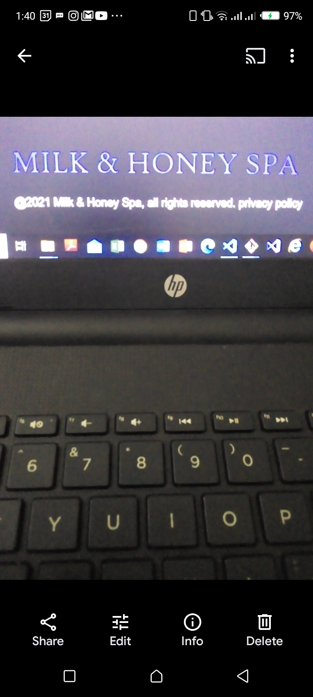

Bug severity: Low

Comment: No comment

Title: Contact Us- Page content showing blur image and wide space

Date: 28/06/2021

Project URL: JustInMind Prototype

Defect Page: Contact Us Page-  Blur image and wide space

Description:

ID – 005

**Steps to Reproduce:**

1. Navigate to Landing page
2. Click on Contact Us
3. Observe the bug

Screenshot:



Bug severity: Low

Comment: No comment